Control Systems Lab Name:___________________

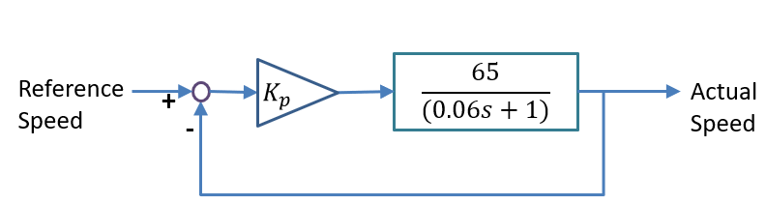
Prelab 6: In Class Assignment RIN:____________Section:__
Consider control of DC motor speed. The transfer function from voltage to speed (in rad/sec) of the motor is $G\left(s\right)= \frac{65}{0.06s+1}$ . The block diagram shows closed loop control of the speed with a compensator, $C(s)$.

Part 1: Proportional Control
- First consider a proportional controller, $C\left(s\right)= K_{1}$. What is the control law? If the desired speed is 155 rad/sec and initially the motor is at zero speed, what is the maximum value of the proportional gain, $K_{1,max}$ that will avoid saturation voltage of 4.8 volts? What is the predicted steady state error for this step in speed using the closed-loop system?

Part 2: Addressing steady-state error with a pure integrator
- To address steady state error, include a compensator pole at the origin: $C\left(s\right)=\frac{K_{2}}{s}$. Draw the root locus diagram for the compensated system. Where is the design point? Using the magnitude condition determine the gain, $K_{2}$ to achieve 10% overshoot, or $ζ=0.591$. What is the settling time for this gain?

Part 3: Addressing transient response with a zero
- Now consider a compensator with a zero, $C\left(s\right)=\frac{K_{3}}{s}(s+z_{c})$, to allow reshaping of the root locus as shown in the diagram below.
  - First determine the desired closed loop pole location (“design point”) such that the settling time is half of what was achieved with the compensator in Part 2, while keeping the percent overshoot the same.
  - Determine the location of the zero, $z_{c},$ that will meet specification by using the angle condition.
  - Optional: If you have time, you can use the magnitude condition to find the gain, $K_{3}$.
